Slow Dance Eyes

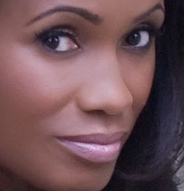

She knows how beautiful her eyes are when they embrace me
So her hair dips over then, to tease
Her smile crescents under, to tempt
Her lips part softly, to tantalize
The eyes, the portal and pool to dive through and into, to submerge and hold ones breathe as the desire encompasses
How shall I love, to touch while gazing, to kiss while devouring, to look deep yet admire from afar?
No words but a coo, a soft “mmmm,” a sudden “oohh” as her eyes bore into me as my fingers dance over her.

She knows how beautiful her eyes are when they embrace me
Deep and dark, light and free, seeing all, wondering much, asking many things, declaring others
Why stop looking into them, why even try? For what purpose? They say all and give the truth.
As they looked up at me, just moments before. As they looked across the room to me, just before the secret smile. As they scanned the street in anticipation, until they moment when they lock on to me and pull me into her love.
The potent part for sure.

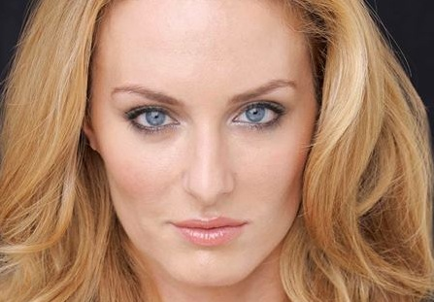

She knows how beautiful her eyes are when they embrace me.

